Skywalker Airlines  
Airline crew scheduler

Requirements Analysis Document

**Team 08**

Rahul Prajapati

Dipal Bhandari

Aniruddh Saxena

Shivani Tamkiya

Alexis Saltzman

# Introduction

## Purpose

|  |  |
| --- | --- |
|  | The purpose of this software is to provide Cornhusker Airlines with scheduling software, allowing the airline crew administrator to schedule staff and airplanes for flights, the crew to search for the schedules, and the public to search for flight takeoff and landing times. |

## Project Scope

|  |  |
| --- | --- |
|  | The crew manager will be able to input and remove information to facilitate the flight and corresponding crew schedules from CHA to three nearby airports: Iowa City, Iowa; Evanston, Illinois; and West Lafayette, Indiana. There are three crew positions: The Captain, First Officer, and Flight Attendant. Each flight has a Captain, a First Officer and one Flight attendant for every 50 passengers. Additionally, the crew will be able to search the schedules for information on flights and working time. The system needs to have backup and restore capabilities. Also, the guest user will be able to search the flight and track them. |

## Objective and Success Criteria

|  |  |
| --- | --- |
|  | There are two types of aircraft at CHA and 3 types of crew members. The scheduler needs to keep track of each flight and its takeoff and landing times as well as  staff and their working hours. The software will have input for all flights then generates flight numbers. The software will be considered successful when it can have this information input, update the information, retrieve the information, and backup and restore the information. |

## Definitions, Acronyms, and Abbreviation

|  |  |
| --- | --- |
|  | CHA - Cornhusker Airways  Captain - Qualified pilot for a particular aircraft  First Officer - Qualified pilot or co-pilot for a particular aircraft  Flight Attendant - Crew member responsible for the safety of the passengers in the main cabin for the duration of a flight.  GBR-10 - Type of aircraft, capacity 45 passengers  NU-150 - Type of aircraft, capacity 75 passengers |

## References

|  |  |
| --- | --- |
|  |  |

## Overview

|  |  |
| --- | --- |
|  | This project is based on a crew scheduling system for Cornhusker Airways (CHA ) that performs various tasks for different levels of administrators. It enables CHA to keep track of employees who are scheduled to be on the aircraft. CHA operates two types of aircrafts GBR-10 and NU-150 with capacity of 45 passengers and 75 passengers respectively. There are different authorization protocols for different administrative positions like qualified Captain, first Officer, flight attendant. |

# Current System

# Proposed SYstem

## Overview

## Functional Requirements

|  |  |
| --- | --- |
| F1 | Place employee to establish the initial airport for a crew member. |
| F2 | Qualify pilot or co-pilot to operate an aircraft. |
| F3 | Create flight complete with flight number, aircraft, origin & destination airports, scheduled takeoff & touchdown times, and required crew members. |
| F4 | Cancel flight, which frees crew members for other flights. |
| F5 | Change crew member on a flight. |
| F6 | Change aircraft for a flight, which cannot be done after takeoff has been set. |
| F7 | Change estimated takeoff time, which needs to automatically update the estimated touchdown time. |
| F8 | maintain updates in an electronic log that can be searched by flight, crew member, airport and/or date range. |
| F9 | Each update in the from n-MMYYY where n is positive integer, MM YYYY are for month and year. |
| F10 | Set actual takeoff time, which will set the estimated touchdown time. |
| F11 | Change estimated touchdown time to account for in-flight delays. |
| F10 | Set actual touchdown time. |

## Nonfunctional Requirements

|  |  |
| --- | --- |
| N1 | Each flight must have sufficient staffing of qualified crew members |
| N2 | An aircraft can’t be flown from CHA if it is not located at CHA |
| N3 | There must be 30 minutes between touching down for one flight and taking off for the next flight for each aircraft. |
| N4 | If a flight delay causes more the time between flights to be less than 30 minutes after the aircraft has landed, either the next flight needs to be delayed to allow for 30 minutes or the aircraft needs to be changed out for a different one that has been grounded for at least 30 minutes. |
| N5 | Flights from CHA cannot use crew that are not located at CHA  N6. Employees can only work up to 8 hours a day. |
| N7 | Employees must have a rest period of 16 hours between work days. |
| N8 | Each airport must have full standby crew members for each type of flight |
|  |  |

## System Models

|  |
| --- |
| Scenarios |
| **Best case**: |
| Manager is able to access the admin page with his credential into the airlines system database and he/she is able to set time the actual time and other administration functionality. After all change manager is able to logout successfully and can see changes in database in real time. |
| **Normal case:** |
| The system is working but at some time it crashes. It means there must be some bug in code. Like might be admin is not able to add an aircraft |
| **Worst case:** |
| The system is not working at all. |

|  |
| --- |
| Use Case Model |
| The system administrator opens the airline website and click on login. They enter their admin username and password. If the credentials are correct, the page is redirected to the administrator control dashboard. If the credentials are not corrected, they are directed to try again.  After logging on:  The system administrator can choose from a dropdown menu to create a new flight. A form is presented with spaces for destination location, departure and arrival times, plane, and dropdown menus for pilot, co-pilot, and crew selection. Only staff that have not exceeded their workday hours will be available in the dropdown menu. The admin presses enter button when complete, and a flight number is automatically created by the system and provided on the confirmation page.  The system administrator can choose from a dropdown menu to edit a flight that has already been created. A search box is presented for the admin to lookup the desired flight. Once the flight is found, the editable fields are opened. Once editing is complete, the admin presses an enter button and is redirected to a confirmation page.  The system administrator can choose to search for information on flights, pilots, co-pilots, and other crew members. The administrator can see all details of item searched, including how many hours employees have worked over a period of time and where employees are currently located.  The system administrator can log off at any time, any unsaved changes will be discarded and the page will redirect to the login page.  Crew members open the airline website and click on login. They enter their username and password. If the credentials are correct, the page is redirected to the crew dashboard, which does not have the creating and editing abilities of the administrator dashboard. If the credentials are not corrected, they are directed to try again.  After logging on:  The crew member can see their schedules on their dashboards. The crew member can search by flight number, airline, or date for all information on flights that match these terms.  Passengers open the webpage. On the homepage, they choose to login. They type in their username and password. If the credentials are correct, they are logged on to their passenger portal where they will see their own flight information as well as a search box with directions to type flight number, airline, or departure city to receive flight information. If their credentials are not corrected they are directed to try again. The passenger chooses to just view their own flight information on the screen after successful login. |

## Object Model

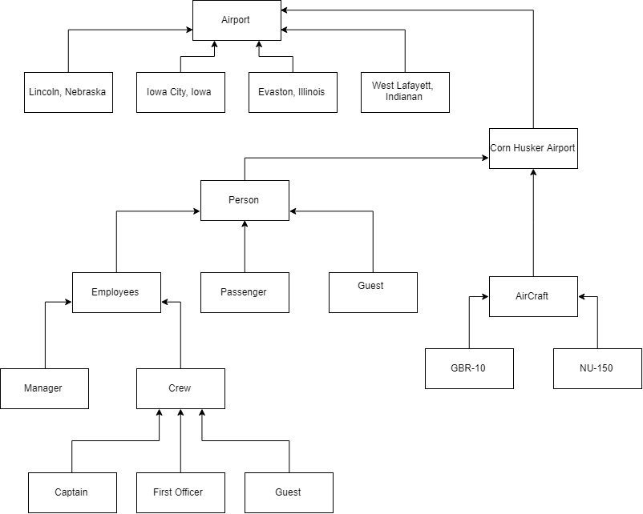

## Dynamic Model

**Manager User Case:**

1. Creating a flight in the airport

DynamicModels/ManagerUseCaseCreateFlight.pdf

2. Setting Time for the flight

DynamicModels/ManagerUseCaseSettingTime.pdf

3. Setting Crew Member

DynamicModels/ManagerUseCaseSettingCrew.pdf

**Guest User Case:**

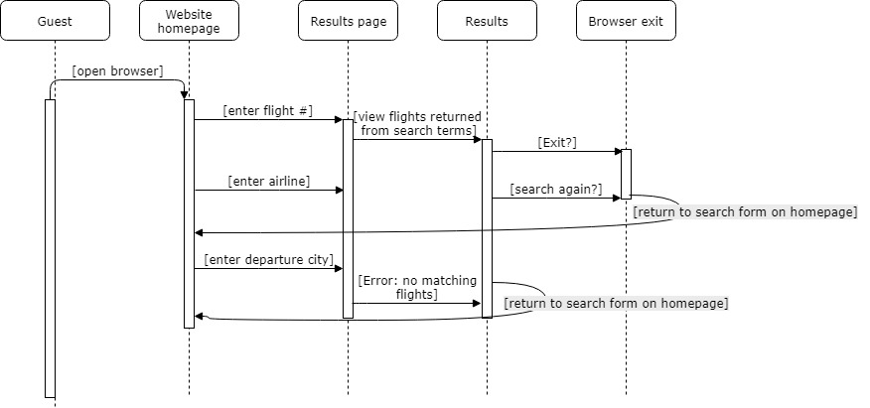

**Passenger User Case:**

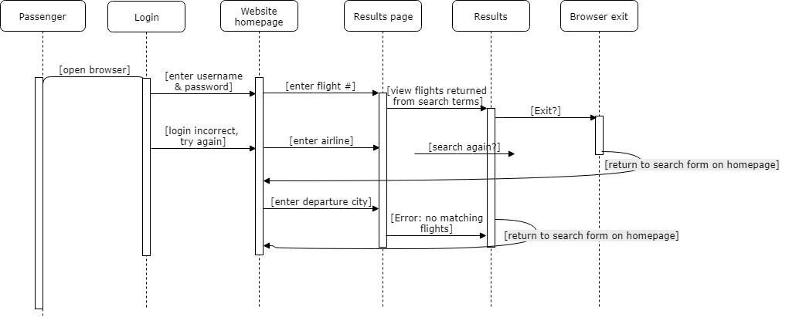

**Crew User Case:**

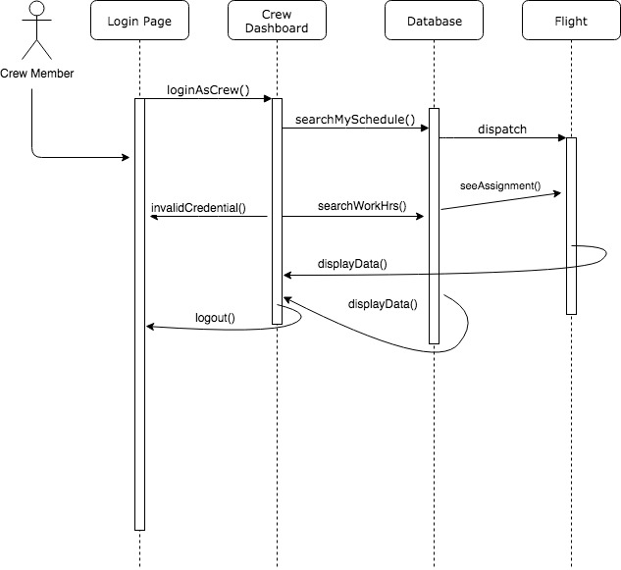

## User Interface: Navigation Paths and Screen Mockups

System Administrator can access privilege service to change or add the functionality like adding flight and crew and also can change or set the flight takeoff and landing time through his/her web application. Crew member can check their time schedule through phone application and airline web application.

# Glossary

Actual Takeoff/Landing – the precise time at which the aircraft takeoff/landed.

Administrator – Someone who has all the access over the system.

Aircrafts – vehicles operated by the Airways.

Captain – a senior pilot who commands the crew of an airplane.

Estimated Takeoff/landing – predicted time at which the aircraft might takeoff/land.

Functional Requirements – describes the functionality of the system.

Grounded – An aircraft not being used for a while.

Non-Functional Requirements – User level requirements including usability, reliability and implementation.

Pilot – a person who flies or is qualified to fly an aircraft.

# 